Managed Mote Application

Setup Guide for Raspberry PI

R 1.5 Updated Jun 26, 2021

# Setup Managed Mote Application Hardware

1. Raspberry Pi 3 Model B+
   1. <https://www.amazon.com/ELEMENT-Element14-Raspberry-Pi-Motherboard/dp/B07BDR5PDW/ref=sr_1_3?crid=1PLDZQP2V4PTJ&keywords=raspberry+pi+3+model+b+plus&qid=1567689685&s=gateway&sprefix=raspberry+pi+3+model+b+plu%2Caps%2C249&sr=8-3>
2. Raspberry Pi RASPBERRYPI-SENSEHAT Sense HAT with Orientation, Pressure, Humidity and Temperature Sensors
   1. <https://www.amazon.com/RASPBERRY-PI-RASPBERRYPI-SENSEHAT-Raspberry-Orientation-Temperature/dp/B014HDG74S/ref=sr_1_1?keywords=Sensehat&qid=1567689543&s=gateway&sr=8-1>
3. Micro Connectors Raspberry Pi 40-pin GPIO 1 to 2 Expansion Board (RAS-GP02)
   1. <https://www.amazon.com/Connectors-Raspberry-40-pin-Expansion-RAS-GP02/dp/B07MCW4KCM>
4. Andrea Communications C1-1021450-100 PureAudio USB-SA External Digital USB Sound Card
   1. <https://www.amazon.com/gp/product/B003VW5Q08/ref=ppx_yo_dt_b_asin_title_o01_s00?ie=UTF8&psc=1>
5. USB to TTL (AOIM) Cable
   1. <https://www.amazon.com/ADAFRUIT-Industries-954-Serial-Raspberry/dp/B00DJUHGHI/ref=sr_1_4?keywords=USB+to+TTL+Serial+Cable&qid=1574328350&sr=8-4>
6. LED
7. USB Power Cable

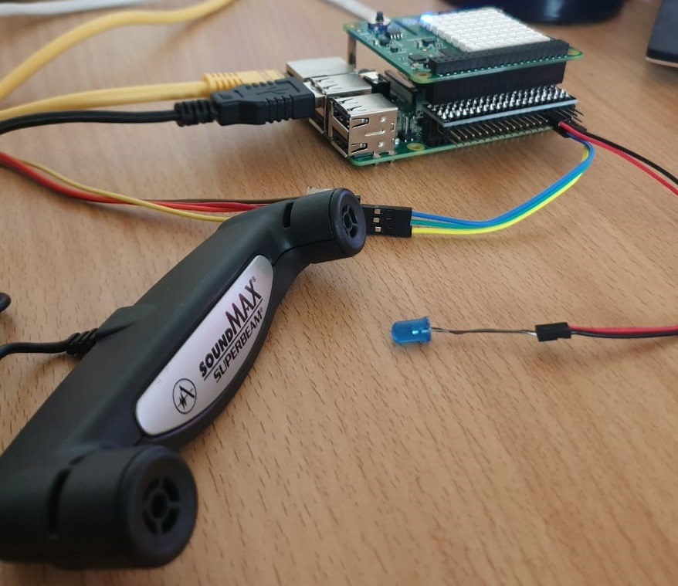

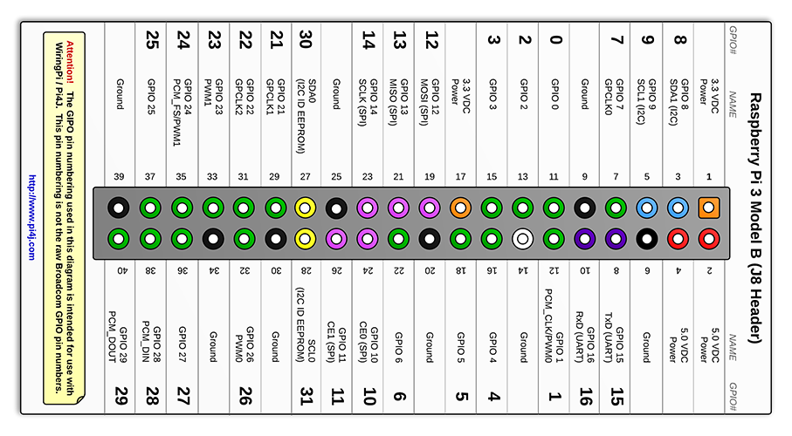

1. Figure 1 shows the Pi connected with the RAS-GP02 to extended the 40-pin header to dual 40 pin headers, one of them used to connect the SenseHat and the other is used to connect the AOIM cable to be connected in TX and RX pins (according to the pin header pins Figure 2)
2. USB Mic can be connected to any USB port.
3. The actuator is designed to be connected to GPIO 0 so you want to have a visual way for the actuator state toggling so you can connect a LED in GPIO 0 to check the open/close toggling.

# Setup Managed Mote Application on Raspberry Pi

Follow the following instructions to run the Managed Mote Application on **raspberry pi 3+**

## Install Raspberry Pi OS

These Instructions shall be run once when using the board for the first time.

1. Download OS zip from <https://downloads.raspberrypi.org/raspios_full_armhf_latest>
2. For raspberry pi we do not have a serial console. We shall rather use HDMI cable and a screen for installation. Please connect Ethernet cable, USB mouse and keyboard to your raspberry pi.
3. Unzip the downloaded zip and an .img format file will be extracted.
4. Insert your SD card in SD card reader of your pc and flash the extracted .img file into your SD card.
5. For Linux host system you can “disks” utility to check the mount point and unmount all partitions (e.g /dev/mmcblk0 ) and then issue following command:
   1. >>sudo dd if=[path to .img] of=[path to mount point] bs=4M
6. Insert the SD card into raspberry pi and keep a note of monitor over HDMI.
7. Raspberry PI OS will boot and prompt will ask you for some basic information like keyboard , location, changing password(To ensure problem free working please change the password) Please select what suits you . When it asks for Wi-Fi information please skip the remaining steps.
8. On your HDMI screen you shall see on the upper right corner a black icon (first one). Please click it as it shall open the Linux console (to be used to setup the mote in the next section).

## Prepare the Raspberry Pi Environment

After install the RASPIOS on Raspberry Pi, there are some needed Application is needed by the mote and the agent needs to be installed first, so follow these instructions:

1. Issue the following command on the consol.
   1. **sudo wget -v -O prepare_rpi_script https://m3-shared-storage.s3-eu-west-1.amazonaws.com/managed-mote/RaspberryPi/Scripts/prepare_rpi_script && sudo chmod a+x prepare_rpi_script && sudo ./prepare_rpi_script**
2. You shall see the following output and the board will be rebooted:

**\*\*\*\*\*\*\*\*\*\*\*\*\*\*\*\*\*\*\*\*\*\*\*\*\*\*\*\*\*\*\*\*\*\*\*\*\*\*\*\*\*\*\*\*\*\*\*\*\*\*\*\*\*\*\*\*\*\*\*\*\*\*\*\*\*\*\*\*\*\*\***

**\*\*\*\*\*\*\*\*\*\*\*\*\*\*\*\* Serial Number : CSP-B827EBDD5BF4 \*\*\*\*\*\*\*\*\*\*\*\*\*\*\*\*\*\*\***

**\*\*\*\*\*\*\*\*\*\*\*\*\*\*\*\* Host Name : csp-b827ebdd5bf4 \*\*\*\*\*\*\*\*\*\*\*\*\*\*\*\*\*\*\***

**\*\*\*\*\*\*\*\*\*\* Raspberry Pi3+ is ready for Managed Mote Application \*\*\*\*\*\*\*\*\*\*\***

**\*\*\*\*\*\*\*\*\*\*\*\*\*\*\*\*\*\*\*\*\*\*\*\*\*\*\*\*\*\*\*\*\*\*\*\*\*\*\*\*\*\*\*\*\*\*\*\*\*\*\*\*\*\*\*\*\*\*\*\*\*\*\*\*\*\*\*\*\*\*\***

1. The printed Serial number (CSP-B827EBDD5BF4) is used to create the peripheral on the portal (Save this Serial Number).
2. The printed Host name (csp-b827ebdd5bf4) is used to SSH to the board using Putty by writing the Host Name instead of the Board IP and use port 22 (Save this Host Name).
3. Now the raspberry pi 3 environment is ready for Managed Mote Application.

## Create Peripheral on the portal

Create a new peripheral on the portal with same as the serial number of the RPI board, Follow the information in the snapshot.

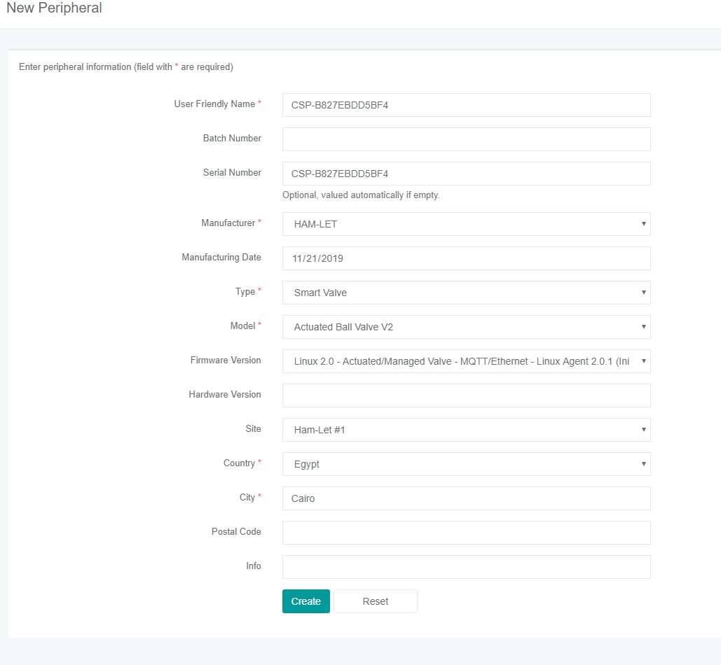

## Setup the Managed Mote Application

Now the RPI is ready to run the managed mote application automatically at the start up, so follow these instructions:

1. Issue this Command to setup the Latest version of Managed Mote Application:
   1. **sudo wget -v -O setup_rpi_script https://m3-shared-storage.s3-eu-west-1.amazonaws.com/managed-mote/RaspberryPi/Scripts/setup_rpi_script && sudo chmod a+x setup_rpi_script && sudo ./setup_rpi_script**
2. To download a specific version of the mote application just execute the command with the version number and the End (as an argument for the download script)
   1. **sudo wget -v -O setup_rpi_script https://m3-shared-storage.s3-eu-west-1.amazonaws.com/managed-mote/RaspberryPi/Scripts/setup_rpi_script && sudo chmod a+x setup_rpi_script && sudo ./setup_rpi_script 3.9**
3. The script will ask you about some configurations to be entered
   1. MoteType (managed/unmanaged)
   2. If unmanaged selected, you will be asked to enter :
      1. Device id
      2. Broker ip
      3. Broker port
      4. Broker username
      5. Broker password
      6. Broker security mode (Open/TLS)
   3. Temp/Humidity Sensor source (sensehat/external)
4. The Mote will be started automatically and will also be started after each reboot
5. A LED in the LED matrix is used to indicate the mote status:
   1. Yellow: Means that the mote is initializing the Agent or the Agent is waiting for MAT Injection (Mote Provisioning discussed next).
   2. Green: Means that the mote is in INIT state.
   3. Blue: Means that the mote is in ONLINE state.
   4. Red: Means that the mote is in OFFLINE state.
   5. Off: Means that the mote is turned off.
6. If you running the Application for the first time so the Yellow LED will take more than 10 sec so this is means that the Agent is waiting for MAT injection using AOIM cable and M3 Mote Application.
7. When the LED turns to Green so the MAT injection and the Agent initialization is done successfully.
8. The blue LED indicates that the mote is on Online State and running.
9. To display logs in SSH session, use this command
   1. tail -f /usr/local/mgc/managed_mote_application/Logging/log.txt

## Provisioning the Managed Mote Application

1. First Device Setup Application (DSA) v6.5.0 is needed and can be downloaded from here:
   1. https://m3-shared-storage.s3-eu-west-1.amazonaws.com/apps/device-setup-client/releases/6.5.0/M3+Device+Setup+Setup+6.5.0.exe
2. the provisioning is done using the serial port (UART) so the USB to TTL (AOIM) cable is needed to be connected to the UART pins in the raspberry pi as follow
   1. AOIM Ground cable -> RPI pin 6
   2. AOIM Tx cable -> RPI pin 10
   3. AOIM Rx cable -> RPI pin 8
   4. AOIM 5v cable -> Not Connected
3. Open the DSA and inject MAT to the mote

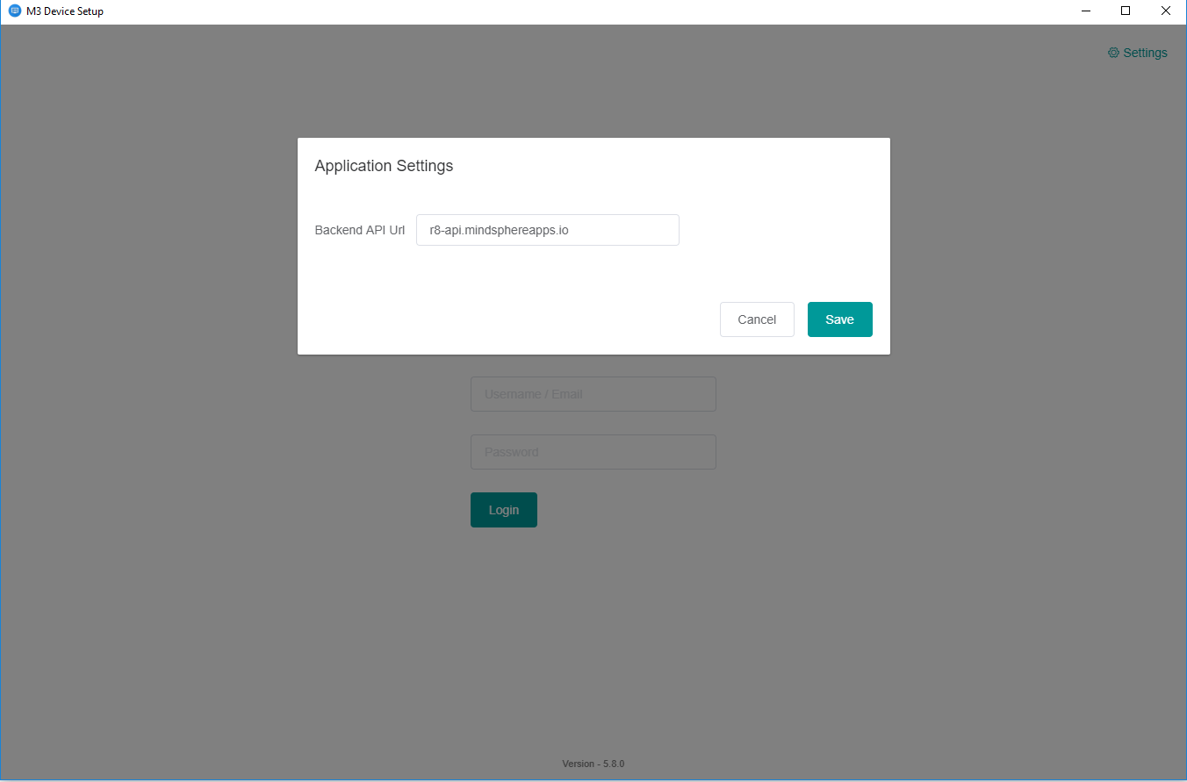

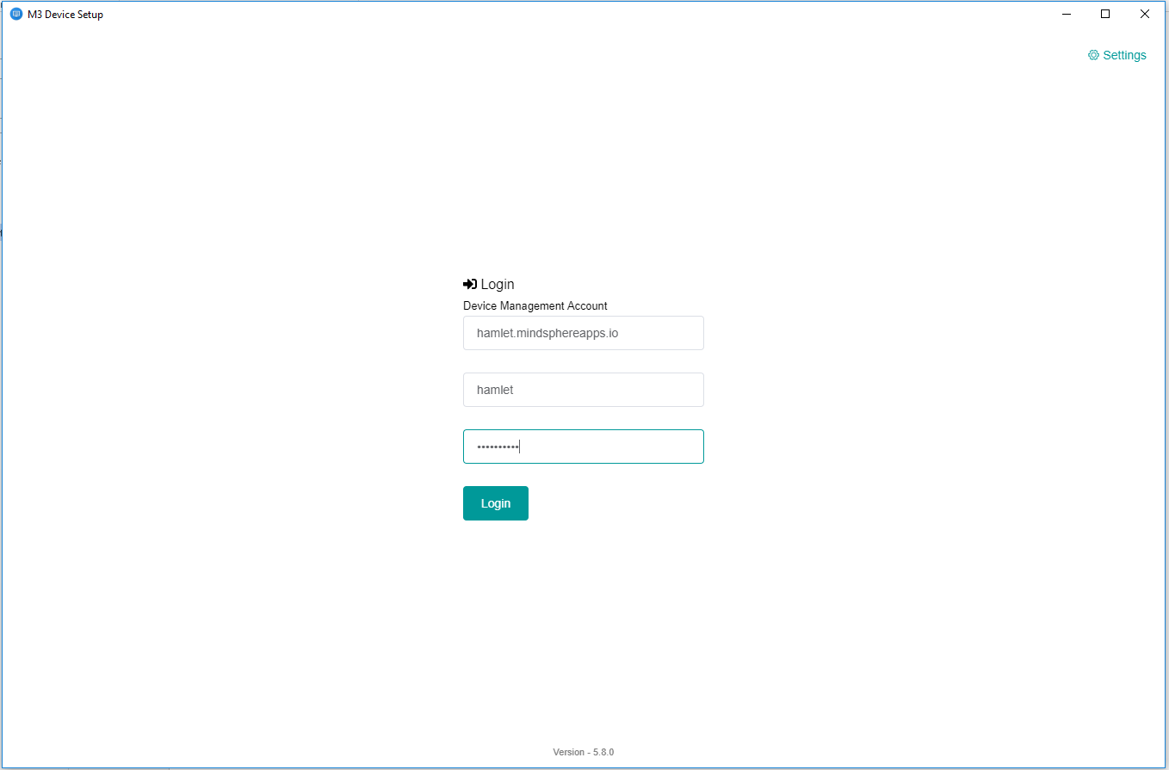

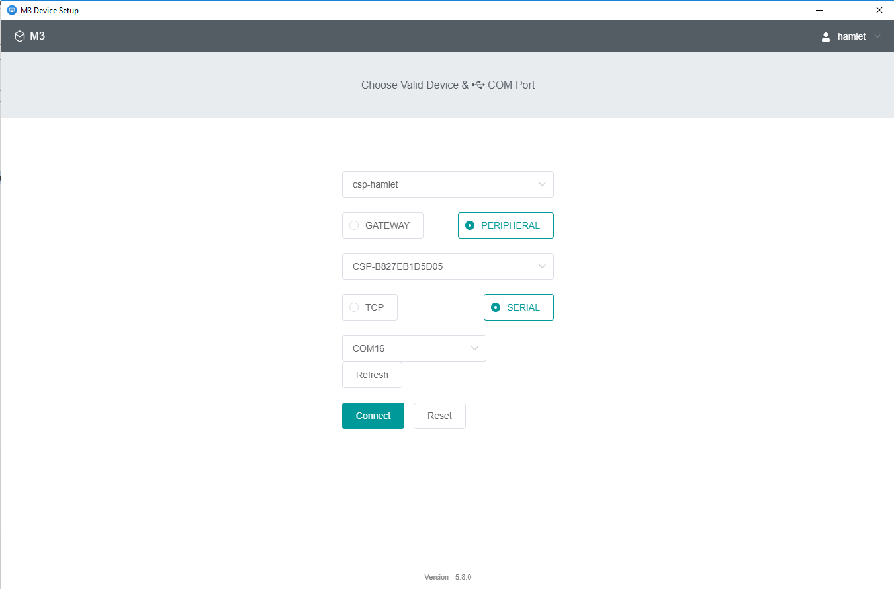

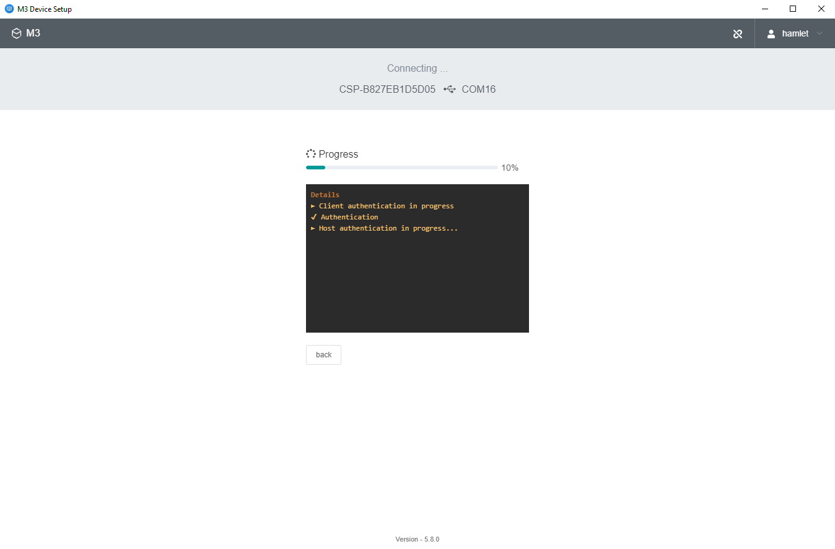

Everything is done ok

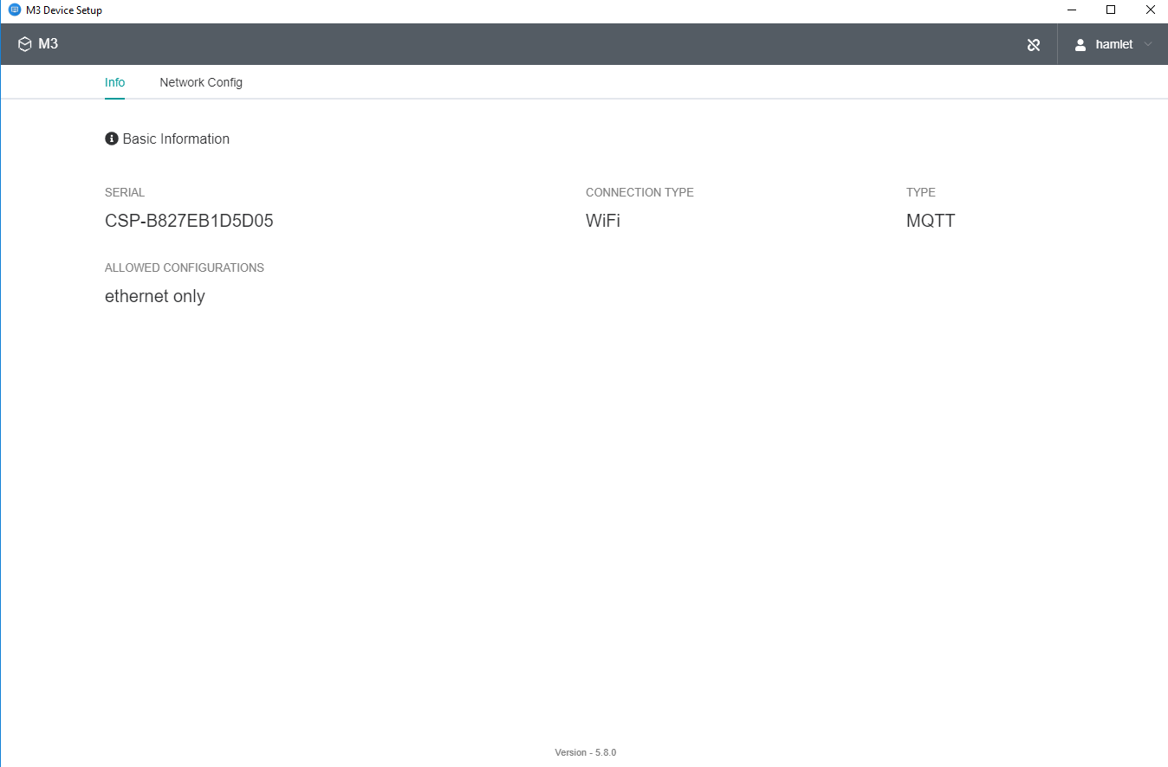

## Cleanup the Managed Mote Application

If you want to stop the Application from running automatically at the Rpi startup, so follow the instructions:

1. issue this command to cleanup the Managed Mote Application:
   1. **sudo wget -v -O cleanup_rpi_script https://m3-shared-storage.s3-eu-west-1.amazonaws.com/managed-mote/RaspberryPi/Scripts/cleanup_rpi_script && sudo chmod a+x cleanup_rpi_script && sudo ./cleanup_rpi_script**